Track Changes Tutorial for Microsoft Word 2010 & 2013

With Track Changes on, it is easy for all parties to see at a glance what has been changed in the text. This tutorial will guide you through the easiest ways to use customizable features of Track Changes to make the tech side of the editing process as smooth as possible. Please note that this tutorial uses directions and screen shots for Word 2013; however, I believe 2010 is very similar.

With this document open, select Review from the menu ribbon (also called the toolbar) across the top of the Word program. Among the displayed buttons, you will see Track Changes. You can click the button to turn the feature on and off.
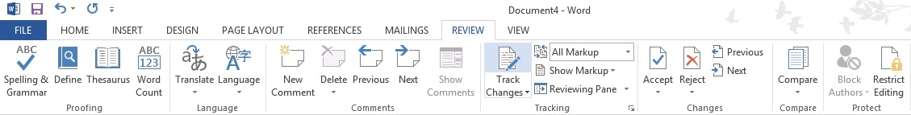

A keyboard shortcut for quickly turning Track Changes on and off is to simultaneously press the CTRL + SHIFT + E keys.

Comment bubbles are the best way for us to communicate with each other regarding specific passages. Right click within a document and select New Comment from the pop-out menu that appears, or, on the Review ribbon up top, click the New Comment icon. The word to the left of where your curser is placed will automatically be highlighted and a comment bubble will appear in the margin. If you want to be more specific about what your comment applies to, highlight the words/paragraphs first and then click New Comment.

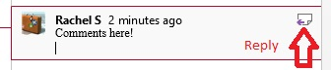
To reply to a comment, hover over or click within the existing comment and you’ll see a reply button in the upper right corner of the comment.

There are different ways of viewing the edited text.

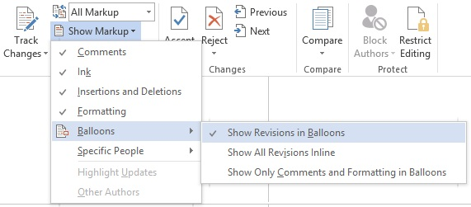
Let’s start with the Show Markup field, accessed up in the Review ribbon. Most likely you’ll want every option to have a check mark, which means all types of edits are displayed. The only feature we’re going to look at for now is the Balloons option. I highly recommend that you always use Show Revisions in Balloons. Go up to your ribbon bar and select this mode now. This mode keeps the body of the document clean and straightforward. The alternative is to Show All Revisions Inline. Go up to your ribbon bar and switch to this mode. This option often causes frustrations and leads to mistakes because the body of the document quickly becomes cluttered, and changes, spacing, and punctuation marks can get lost in the sea of color.
Please return to Show Revisions in Balloons for viewing the rest of this tutorial.

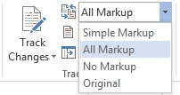
Next we’ll look at All Markup vs. Simple Markup. (It’s unlikely you’ll ever need No Markup or Original.)

Start by viewing this paragraph in All Markup mode. You should see dots leading from a deleted portion of text to a notation in the right margin, added text appears colored and underlined, like this, and comments are fully visible in the right margin. A grey vertical bar should be visible along the left margin and a colored vertical bar should be visible along the right margin, both of which serve as a visual cue that there is a change somewhere in the line of text. This is a helpful visual for making sure no one misses something small, like a changed punctuation mark. Now go up to your Review ribbon and change the view to Simple Markup mode and compare the differences in this paragraph. In Simple Markup, only a colored vertical line appears along the left margin, and a comment symbol is visible in the right margin. I recommend you always do your initial edit review in All Markup mode to help ensure you don’t miss any edits. Simple Markup may come in handy if you want to do a final read-through with less clutter on the screen.
Please revert back to All Markup mode for viewing the rest of this tutorial.

Another major change that can affect the way you view edits is to view the document in Read Mode instead of Print Layout. You may find Read Mode helpful during late drafts when you aren’t changing much, but since you can’t make any edits without switching back to Print Layout (unlike in earlier versions of Word), it can be a hassle during early drafts with frequent edits. You can access Read Mode by clicking View in the toolbar at the top of Word and then selecting Read Mode or by clicking the icon in the lower right corner of the screen.

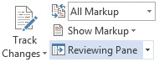
The last big option for how you view edits is whether to use the Reviewing Pane. Personally, I find that with All Markup and Show Revisions in Balloons both turned on, the Reviewing Pane is unnecessary, but it’s purely personal preference, so play around with what works best for you.
Now let’s look at the Accept and Reject icons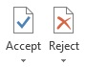 in the Review ribbon. These options also appear if you right-click next to edited text in the body of the document or a balloon in the right margin. If you are happy with something I’ve edited, no need to use the Accept Changes feature to individually accept every little thing, just leave as is. (We can do it all in one fell swoop at the end, but more on that in the next paragraph.) If you would like to stet an edit (editing term meaning “let it stand,” used when you don’t want to accept an editor’s change) and the manuscript will be coming back to me, I prefer that you do not use the Reject Changes feature. Instead—with Track Changes turned on—delete the edit and rewrite your preference. By doing this, when I next see the document your stet will be visible to me, and I’ll be able to learn from the types of edits you tend not to want. If you want to query one of my edits, or let me know why you’ve decided against an edit so that I can be guided by your preferences moving forward, create a Comment. If we’re at our final stage of working together and the manuscript will not be seen by me again, feel free to use the Reject Changes option if you find it easiest.
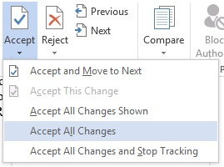
After my final edit has been completed on your document and you’ve gone through every line to stet changes by either using the Reject button or rewriting, you’ll want to create a clean draft for your next editor, the proofreader, formatter, etc. by using the Accept All Changes option. This will incorporate all changes, yours and mine, into the manuscript. Before you click it, though, I recommend you save the document as a new file so you have the Tracked version to refer back to should any queries arise later. You’ll still need to manually delete any remaining comment bubbles.

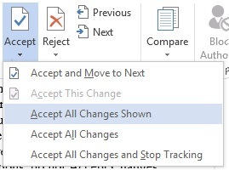
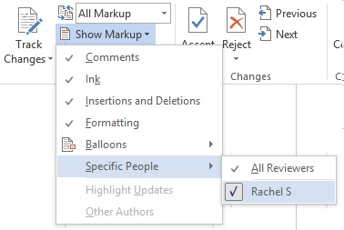
The last features I’ll mention gives you the ability to view edits based on user and accept only a specific user’s changes. It’s unlikely you’ll need to use these options, but I’ll explain the features in context of how they help an editor so you can understand how and why these features could be put to use.
After I’ve copyedited a file and sent it to the author for review, the author sends me back a file that shows their new edits as well as my old edits. The first thing I do is go to the Show Markup field up in the Review toolbar, click Specific People, then deselect my author’s name. What this does is show me only my own edits within the document. I know the author has already gone through and deleted the edits they didn’t like from my previous phase of editing, which means they are happy with all of the remaining edits that I’m now looking at. To clean up the document, I then click the downward arrow under the Accept button and select Accept All Changes Shown. All of my previous edits are then fully incorporated into the text, and all that remains of my previous work are my comments, which I’ll delete individually. I then go back into Show Markup > Specific People, and reselect my author’s name so I can once again see their new material while I read and edit.

And those are all the basics! There are, of course, additional features and settings, and you may prefer alternate settings to what I’ve recommended, and that’s absolutely fine. Please email with any questions you may have. Happy editing!

